**Topic 6: Hypothesis Testing Solutions**

**Q1**

a) H0:   
H1: 

b) A Type I error is the mistake of **concluding** that the mean number of hours studied at your school is **different** from the 14.6 hour benchmark reported by Business Week when **in fact** it is not any different.

**(**Type I Erroroccurs if reject thewhen it is true)

c) A Type II error is the mistake of **not concluding** that the mean number of hours studied at your school is **different** from the 14.6 hour benchmark reported by Business Week when it is **in fact** different.

(Type II Erroroccurs if do not reject thewhen it is false)

**Q2**

a) 

Let  be the population mean of withdrawal

Population distribution unknown,  n = 36> 30, by Central Limit Theorem, the sampling distribution of  is approximately normal

 known (=30)  Z test can be used (Lower-tail test)

At , Critical value = -Z = -1.645

Reject H0 if Z < -1.645



Since Z = -2.4 < -1.645, Reject H0 at 

There is sufficient evidence that the population mean amount of money withdrawn from ATMs per customer transaction is less than $160.

b) p -value = P(Z $≤$-2.4) = 0.0082

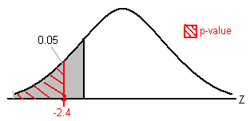Probability of obtaining a test statistic -2.4 or less is 0.0082, given H0 is true.

**Q3**

1. H0: 

H1: 

 n = 50 > 30 from unknown population distribution, by Central Limit Theorem, the sampling distribution of  is approximately normal

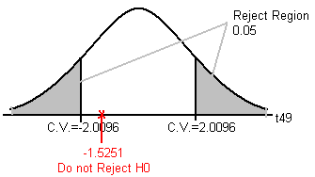   unknown  t test should be used (two-tail test)

, Critical value =

Reject H0 if t < -2.0096 or t > 2.0096



Since t = -1.5251 >-2.0096 and <2.0096

Do not Reject H0 at 

There is insufficient evidence that population mean amount is different from 8.17 ounces.

1. p -value = =

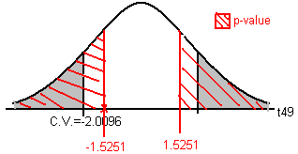 = 2 x (0.05,0.1) = (0.1,0.2)

**Interpretation:**

Probability of obtaining a test statistics 1.5251 or more or -1.5251 or less is between 0.1 and 0.2 exclusively, given H0 is true.

**Q4**

1. H0:   
   H1: 

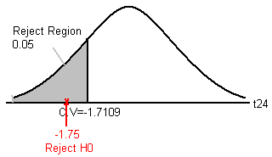  the population is normal distribution, the sampling distribution of  is also normal distribution  
   unknown  t test should be used (lower-tail test)  
, Critical value =-  
Reject H0 if t < -1.7109



Since t = -1.75 < -1.7109  
Reject H0 at    
There is sufficient evidence that the production equipment needs adjustment.

1. H0:   
   H1: 

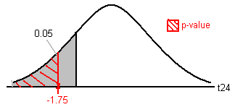  the population is normal distribution, the sampling distribution of  is also normal distribution  
  unknown  t test should be used (lower-tail test)  
  
Reject H0 if p-value < 0.05

   
p -value = P(t ≤ -1.75) = (0.025, 0.05)

Since p-value = (0.025, 0.05) < 0.05  
Reject H0 at    
There is sufficient evidence that the production equipment needs adjustment.

1. Probability of obtaining a test statistics -1.75 or less is between 0.025 and 0.05 exclusively, given H0 is true.
2. The conclusions are the same.

**Q5**

Assume population distribution is normal

Let  be the true average waiting time at back in commercial district.  
H: 5  
H: < 5  
n < 30 and unknown

Use *t*-test

= 0.05, t=-t=-1.7613; Reject H0 if t < -1.7613

$\overline{X}$ = 4.286667, s = 1.637985

t = $\frac{4.286667-5}{\frac{1.637985}{\sqrt{15}}}$ = -1.6867 >-1.7613

We do not reject H at = 0.05. There is insufficient evidence that the population average waiting time is less than 5 mins.

**Q6**

1. As , we need to assume the population distribution is normal.



b) Let  be the population mean of overweight



 ,  is unknown, assume population distribution is normal

Use the t test,  (two-tail test)

; Critical Value 



Reject  if or 

 =10  



=3.7712>2.8982

 We reject.

There is sufficient evidence that the population mean overweight is not 10 pounds

c) Type I error () = Pr (do not agree the claim of 10-pound overweight when in fact the claim is true)

Type II error () = Pr (Agree the claim of 10-pound overweight when in fact the claim is false)

**Q7**

a) n = 40 > 30 and  is unknown, use t-distribution

H: 10

H: > 10  
= 0.01; t = t0.01, 39 = 2.4258  
t =  > 2.4528, as H is rejected

Now sample size, n, n’ = 41, hence

t’ = t0.01, 40 = 2.4233, and

, as a result t’ will be increased

i.e. t’ > t > 2.4258 > 2.4233

 H is still rejected

b) Now’’= 0.05  
t’’ = 1.6839, with 40 degrees of freedom  
t’ > 2.4233 from above  
 t’ > 2.4233 > 1.6839  
Therefore, H is still rejected